**Aerial Photo**

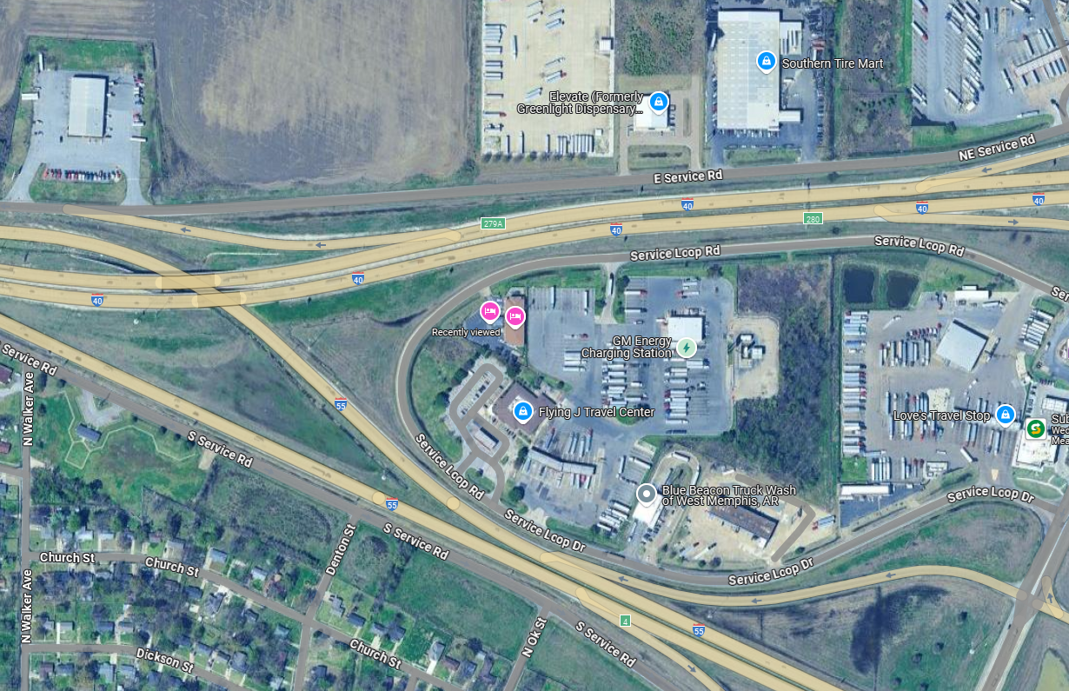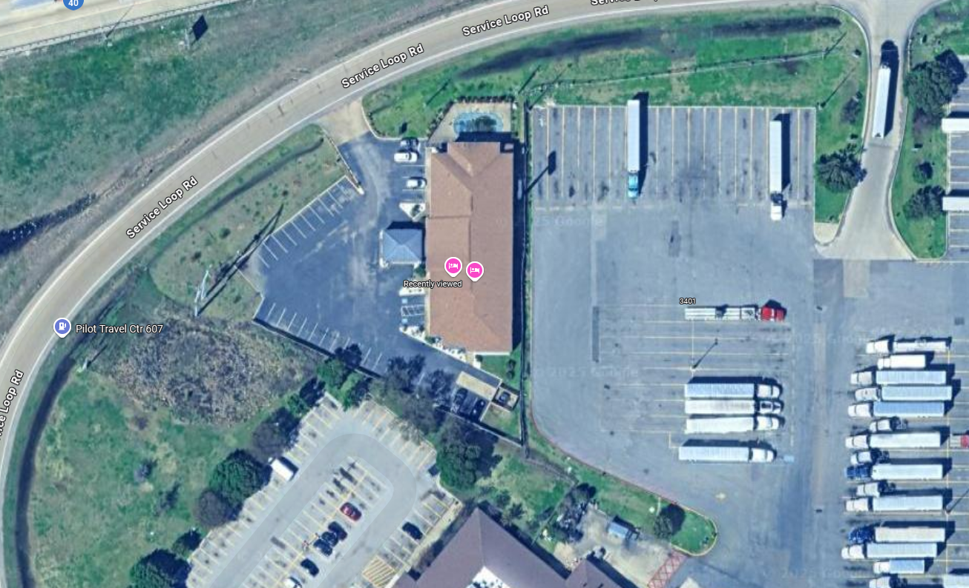

Additional Instructions:

* Pay attention to the image borders color/ size/ placement.
* Pay attention to text font/ color
* Once it is finished – be sure to “group” all the images and lines so it is easy to copy/ paste into final document.
* Details really matter