Images saved in this single word file to keep them together, but you can just save the final copy as a.JPG image file in the folder.

Sample Ground Floor Picture

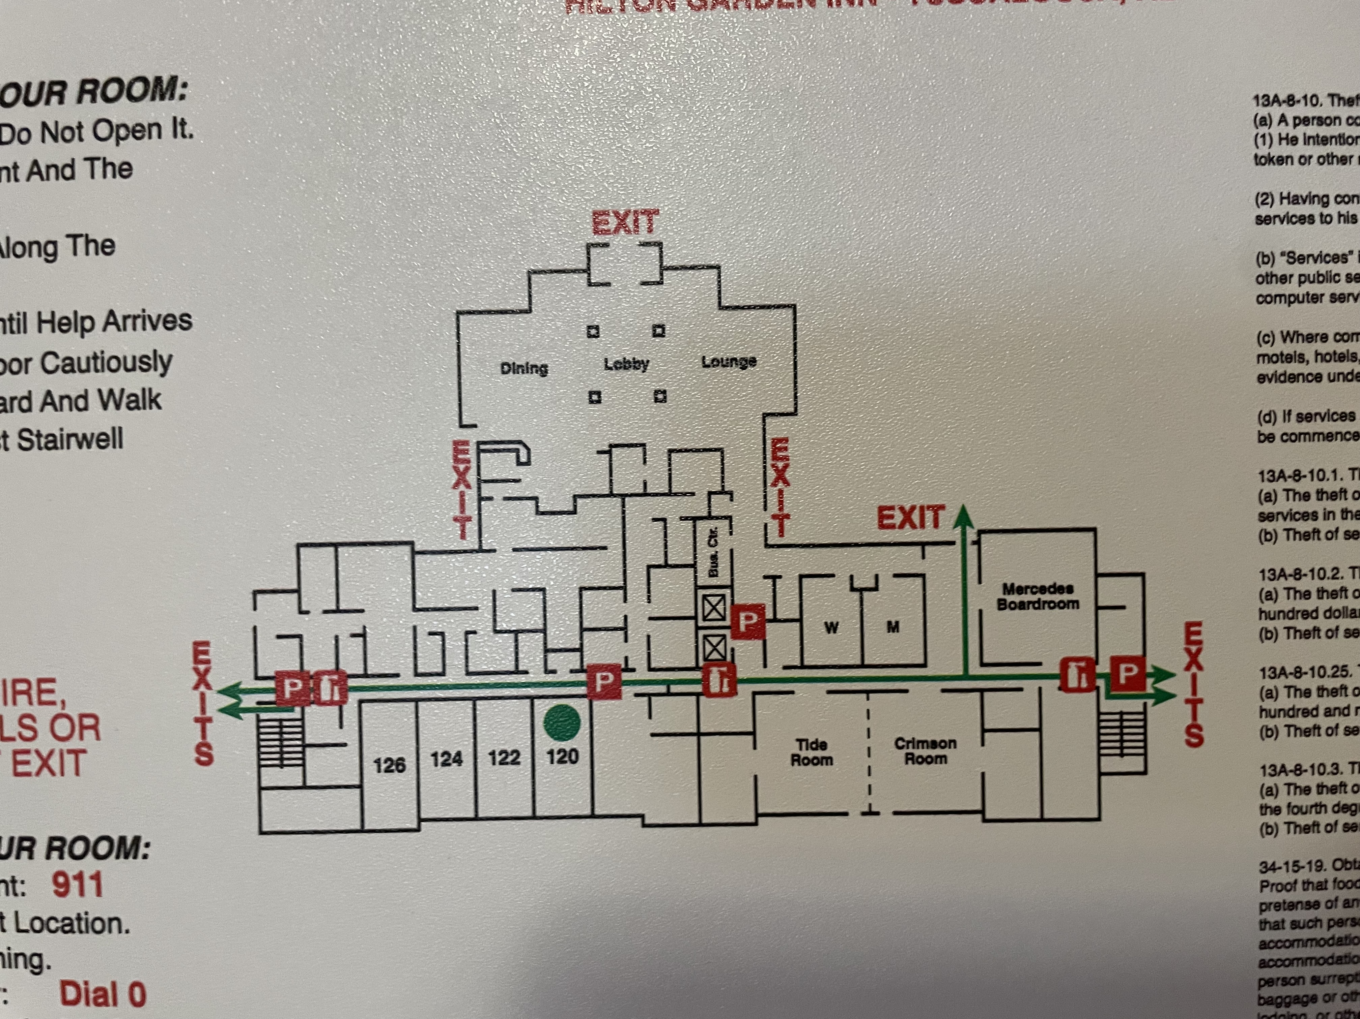
Sample Upper Floor Picture

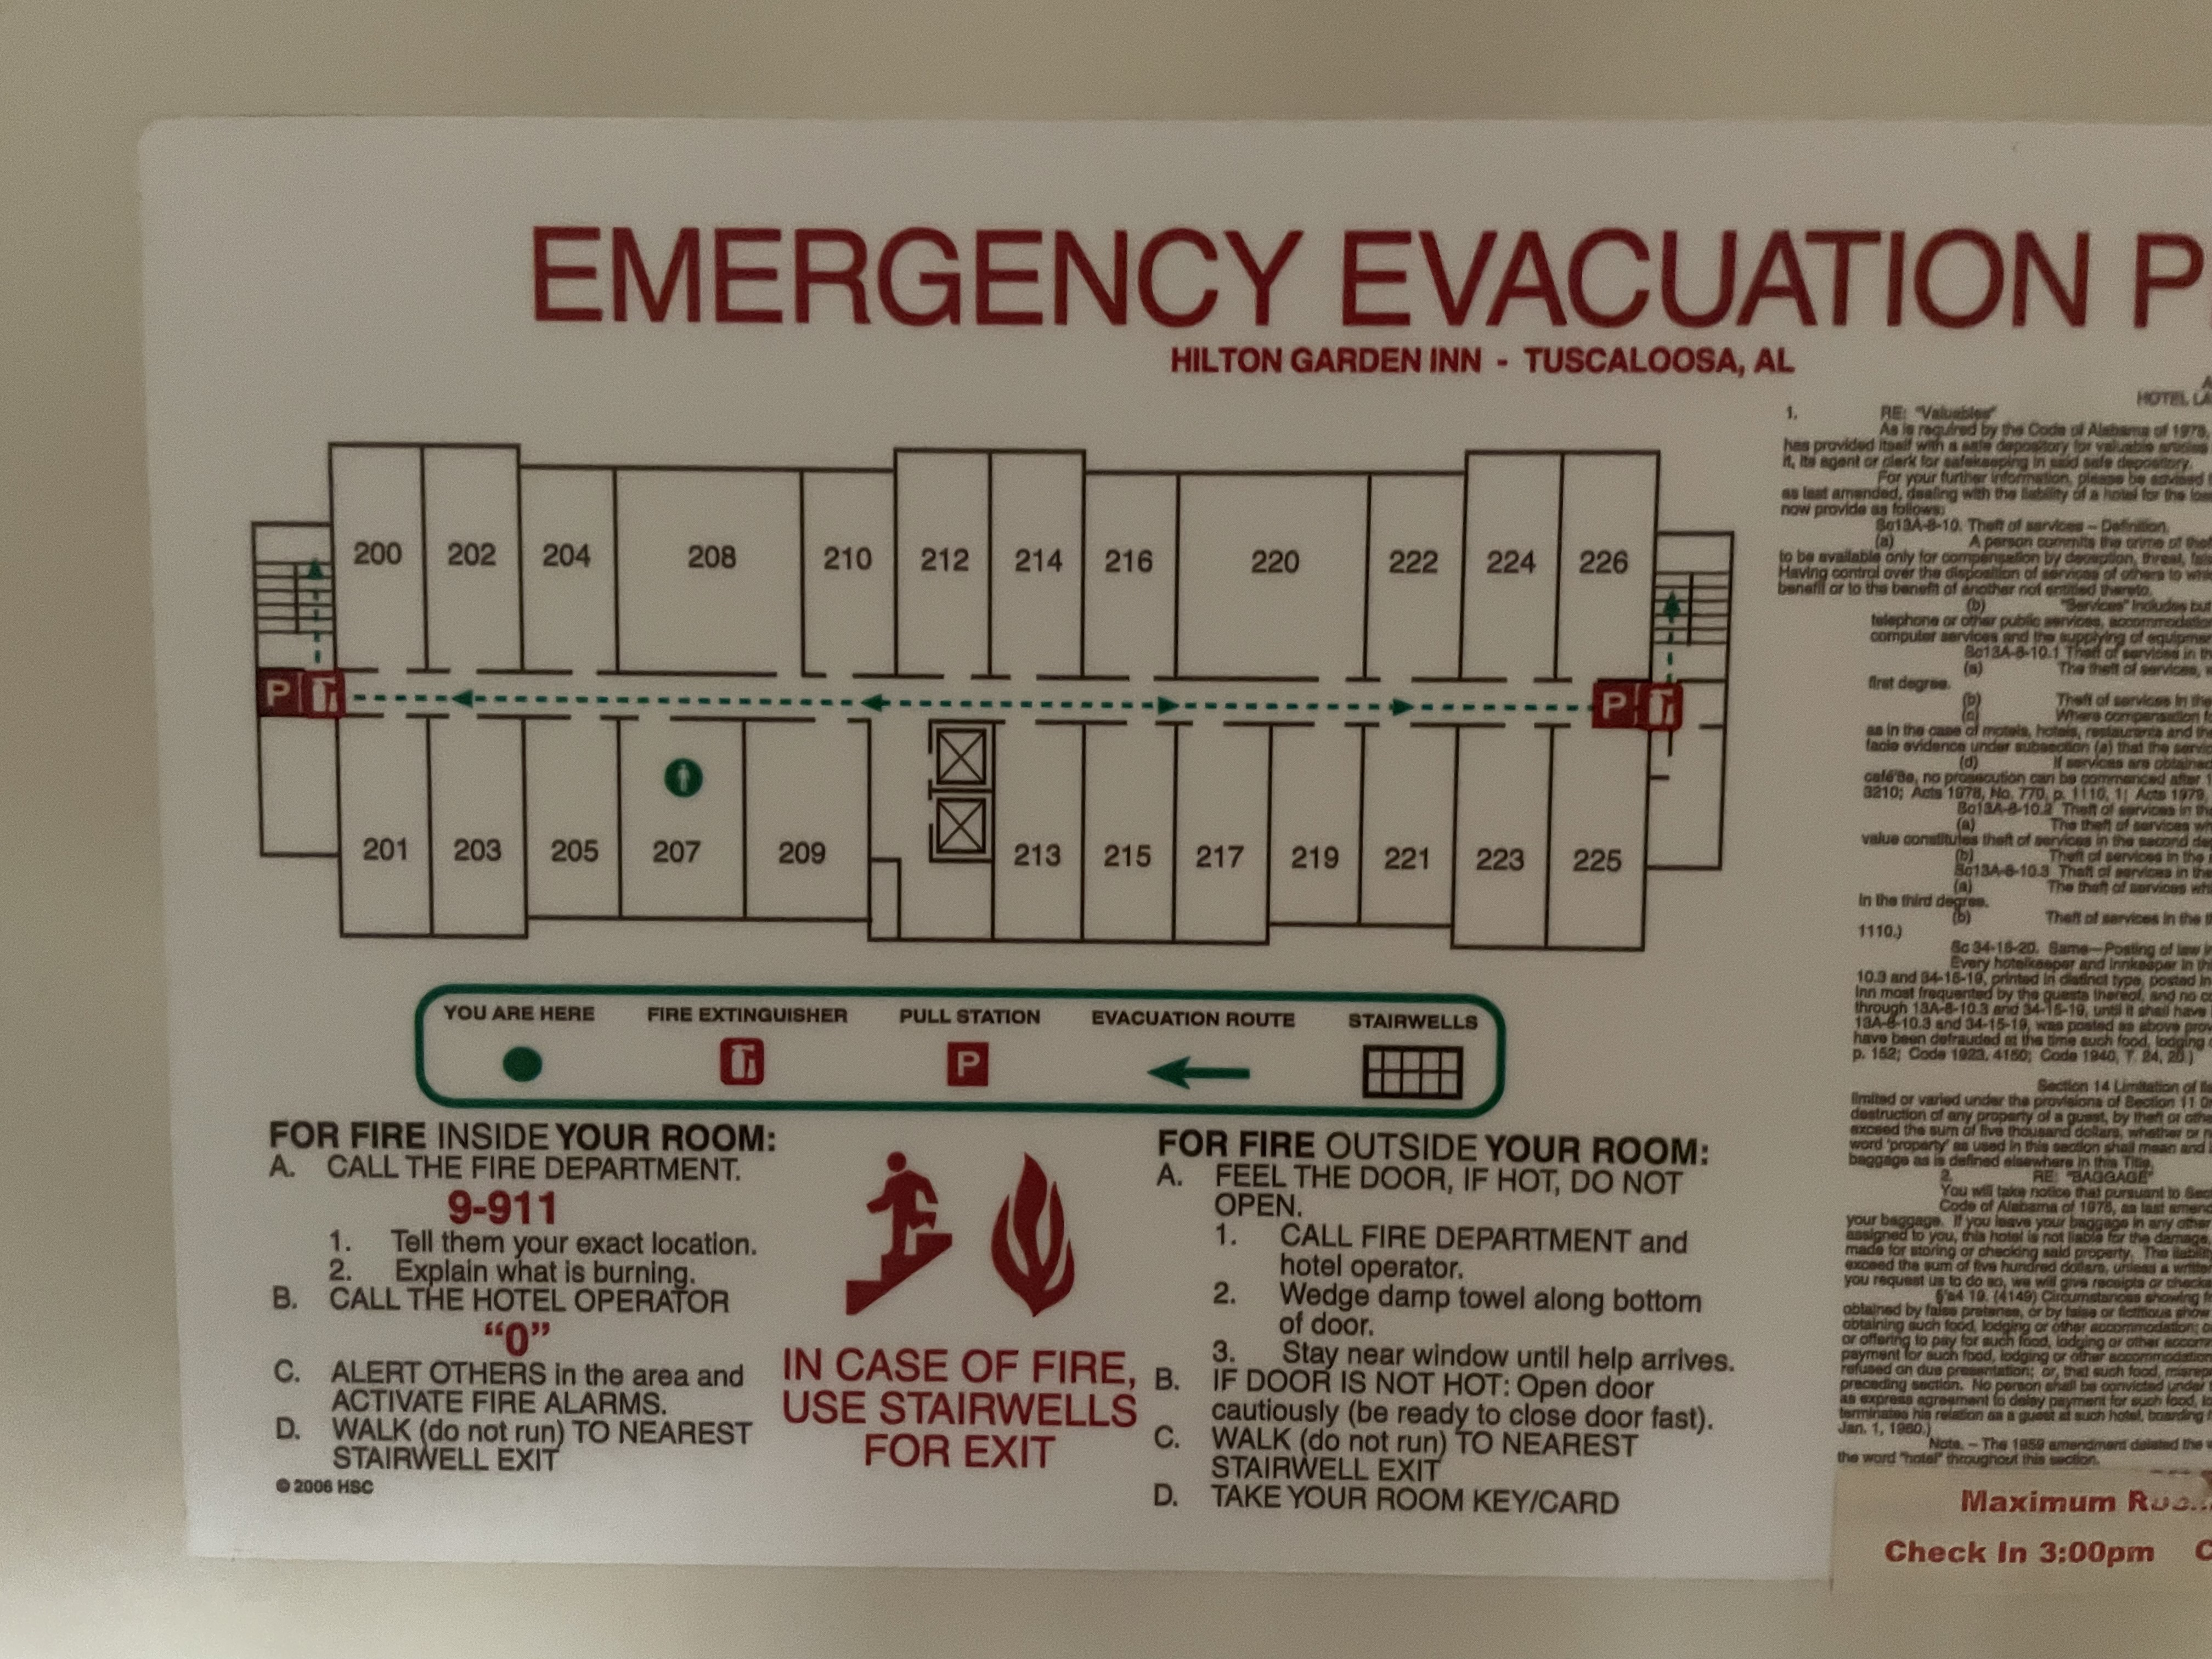
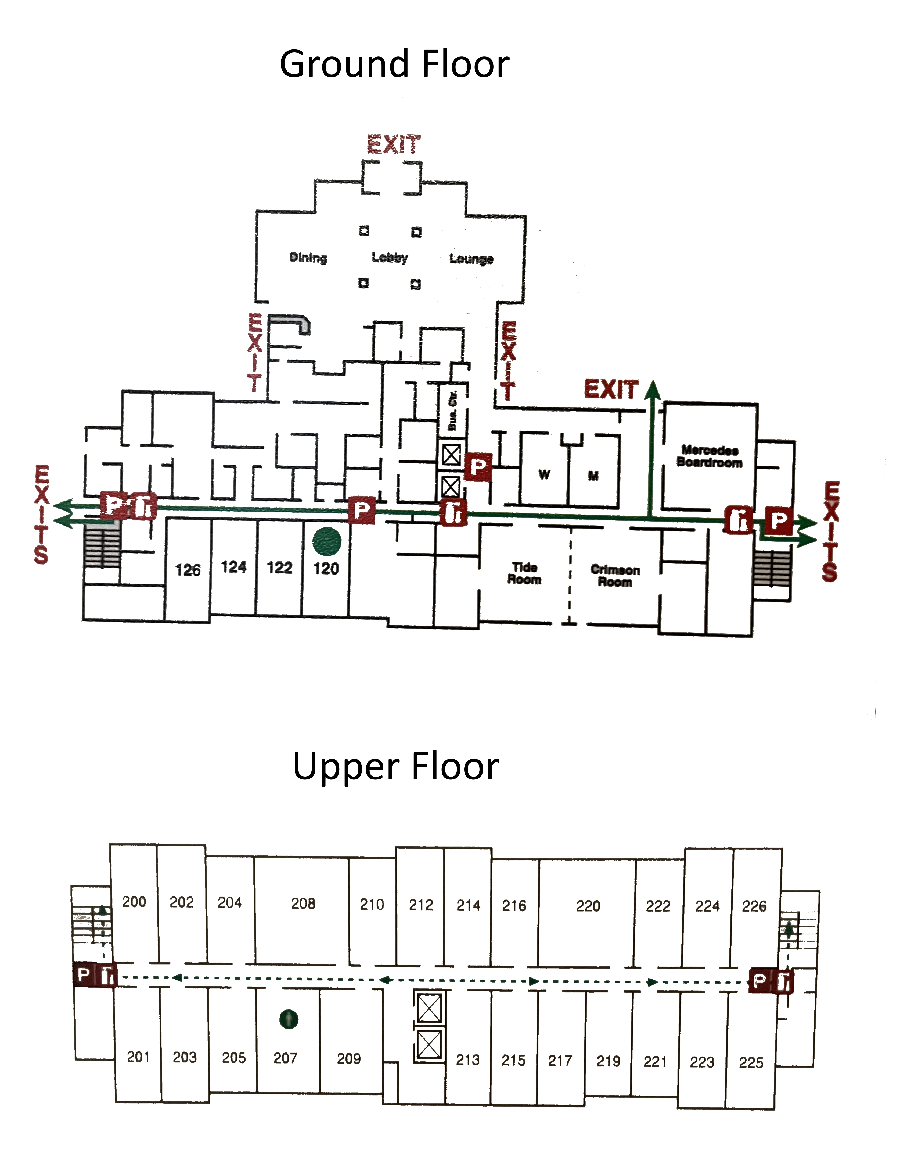
Finished Product

